6th Annual Regional Economic Forecast and Innovation Expo is a Success! CONGRATULATIONS to the Economic Development Directors who again planned and hosted a dynamic and informative regional gathering of business and community leaders. PacMtn actively participated and through a real-time, feedback discussion facilitated by consultant Jason Robertson some of what we learned:
- We have an opportunity to better educate and connect people with public workforce system
- People value different outcomes: evenly divided between job placements and higher wages
- Economic vitality is tied to employee retention and recruitment, as well as partner coordination
At the Upcoming Board Retreat we will examine this as well as the other data gathered over the last 3 months including review of the nearly 100 suggestions businesses made for what we could do to help them. Some of those… job seeker packaging; effective, efficient job matching and job posting to build a qualified pool; providing job readiness and hard skills training to meet business need and offering additional employment follow-up services.

State Workforce Board Recommends 12 Workforce Areas as Regions…pursuant to the Opportunity Act each state must establish regions designed to assure a planning focus on economic factors and service delivery that supports movement across workforce areas. After a very thorough review and discussion of the options the 12 workforce area recommendation is moving to the Governor. This action reaffirms PacMtn as a 5 county planning region.

John Aultman is the new Governor’s Workforce & Education Senior Policy Advisor. John is a former PacMtn WDC Board Member and for seven years served as the Executive Director of New Market Skills Center. John is a known advocate for workforce development, STEM and K-12 learning. We welcome John and look forward to his arrival in early January!
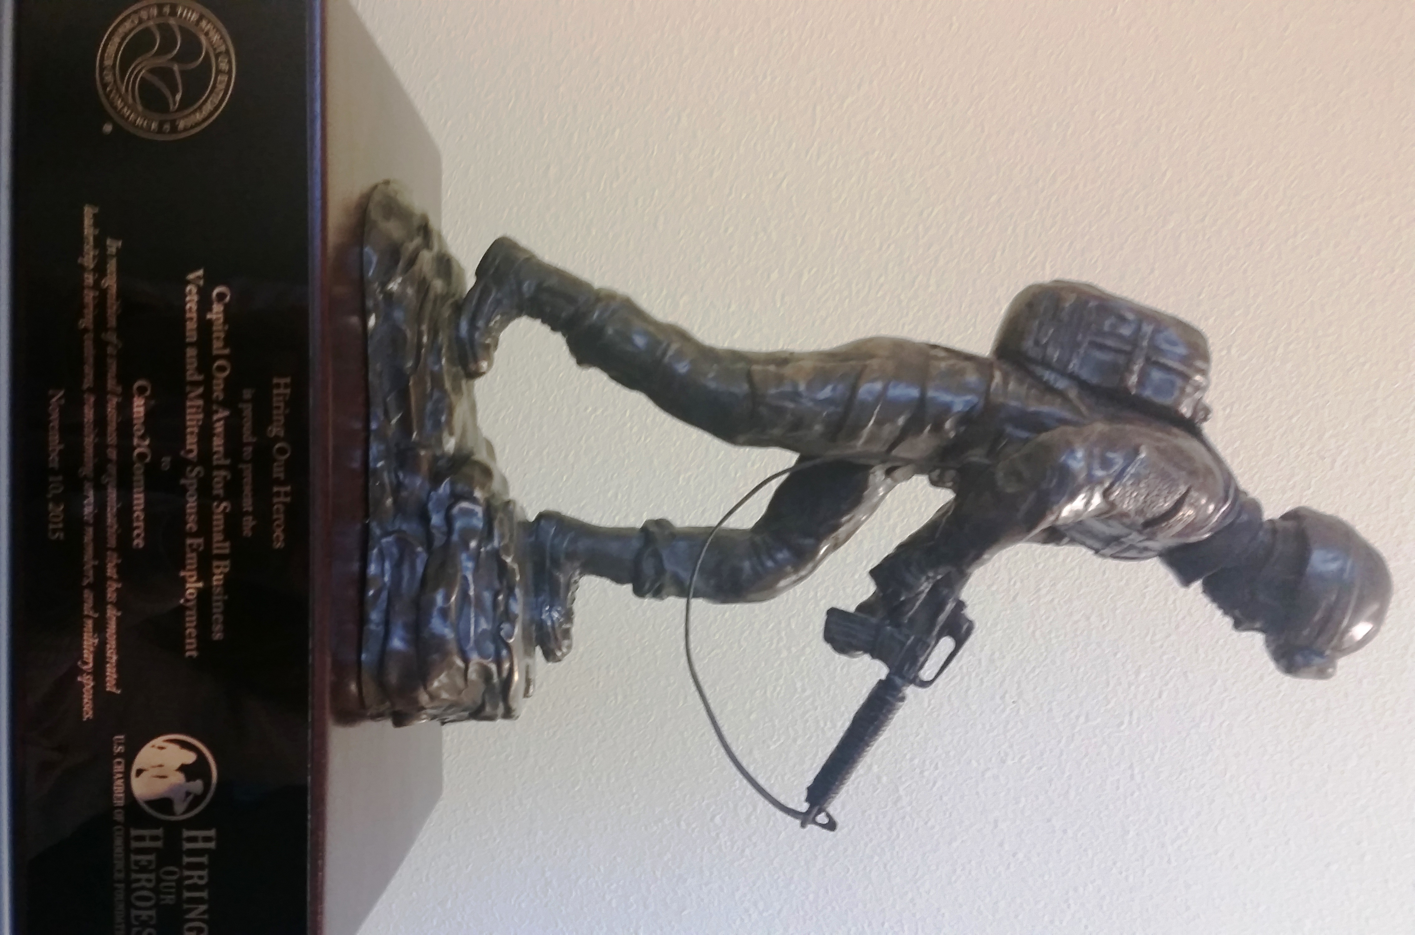
APPLAUSE…. Camo2Commerce Creates BIG wins…to date over 600 former military have been placed into jobs and the 900 enrollment goal is very close. According to the WA Office of Financial Management, and using the first year of C2C data the project generated:
- over $11.7 M in economic activity
- provided nearly $1.2 M in direct state revenue
- saved the Military $1.5 M in decreased unemployment claims
- greater impact for many than those who left with baccalaureate degrees
C2C exemplary work was acknowledged by the US Chamber Foundation who awarded us the 2015 Small Business Award for Placement of Transitioning Military and Spouses. To be nominated as one of three businesses was a large honor, but to walk away with the bronze statue represents huge accomplishment for the C2C staff, partners and the region. Our request for $2.5 M in continued funding for C2C is under review at the national office.

PacMtn invited as trusted advisors…In an effort to improve outcomes for formerly incarcerated youth at Green Hill and those transitioning out of correctional facilities PacMtn staff will sit as advisors and potential contractors, helping Department of Corrections and DSHS Division of Rehabilitation with workforce planning efforts on recently received national funding.

Great Partnership emerging with Timberland Regional Library…Here’s the link http://www.trl.org/About/TodaysLibrary/TRL-Newsletter-NovDec-2015.pdf

Awarded InterCity Bus Passes…Thank you to InterCity Transit for the Discounted Bus Passes. We were able to receive 36 adult passes at a 50% discount. These passes are helpful removing transportation barriers for customers doing interviews, doing job search or going to school.

Making an Impact---Youth Lives…Uplift! is a PacMtn Youth and Young Adult program funded from Governor’s Workforce Discretionary Funds. A key component to what helps Uplift! work well is the focus on relationship development within the group. On the final day of a recent Uplift! training people were excused, but participants continued to sit in the training room and talk to one another. After an hour and twenty minutes, one of the youth said they had to leave because they had to go to the job they gained with the help of Uplift! The rest of the youth, one at a time, left begrudgingly, after getting contact information for each other, and making plans for a reunion meeting. Uplift! assists in gaining employment, but it also builds a community that is crucial for long-standing youth engagement and success beyond a formal program.

Speaking of young adults, AmeriCorps are having an impact in the Resource Center at WorkSource Thurston where they are building a cadre of young adult volunteers who will help computer users navigate on-line resources and along the way build their confidence, teaching skills and ability to demonstrate real work experience.

Former Simpson Employee Update…With the opening of the WorkSource Transition Center we have been able to connect people to excellent services and track what happens.
Total Impacted Employees |  | 275
Trade Act Training |  | 119
Worker Retraining @ Colleges |  | 26
Wood Products Jobs |  | 42
Other than Wood Product Jobs |  | 27
Retired |  | 20
Transfer to other Simpson Jobs |  | 7
Self Employed |  | 3
Total Known Placements |  | 244
Unknown |  | 31

Board Query…keeping track of what is asked of staff.
Date | Issue | Response/Resolution
10/22 | Community Summer Youth Employment funding for 2016 | The PY16 funding process: mid-April, the Executive Finance Committee will host a Budget Workshop for Board Members to learn about anticipated budget revenues and offer ideas and recommendations for consideration. Staff will use that information to build the Preliminary Final PY16 Budget that goes to the Executive Finance Committee (E-FC) for review, discussion and recommendation, including any special summer youth employment funding. The full Council will consider and adopt the budget before June 30. If the Board approves summer youth employment funding we will work to expedite the process to get interested contractors aboard as soon as we can. We are also working on other projects that may provide job opportunities for youth. Making sure we have a good contact point for sharing that information with potentially eligible youth in East Lewis County will be important.
 | PacMtn Website  - Locating Board Minutes  - Committee Agendas and Notes | Currently, all Board Agenda and Minutes are located on the website. Staff are also working to add to the website so that we can house Committee Meeting Agendas and Notes, see a calendar of activities and enable additional useful Board Member resources to be easily found.
 | Project Tracking  - Quarterly YTD Reporting | See attached Quarterly Report to be reviewed by Executive Finance Committee and made available under Board Resources
 | Recreation/Tourism is the #6 PacMtn Industry Cluster | Commitment for consistent inclusion in all PacMtn documents

