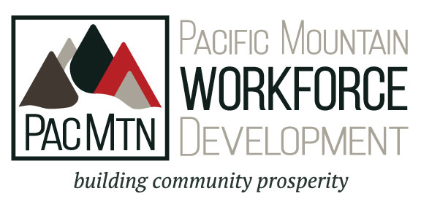

Board of Directors
Recruitment Packet

Board of Directors Recruitment Packet

Learn About PacMtn
- Mission, Vision and Goals—page 3
- WDC Roles and Relationships—page 4
- PacMtn At a Glance—pages 5-6
- Industry Sector Information—pages 6-7
- Join the Board of Directors—page 8
- Recruitment Overview, Procedures, & Timeline—pages 9-10
- Board Member Job Description—pages 10-13
- Board Member Application Process—page 13
- Board Member Application—pages 14-15

Mission, Vision, & Values

MISSION
To lead dynamic regional workforce development that enhances economic success.

VISION
PacMtn is a recognized leader providing workforce solutions in Grays Harbor, Lewis, Mason, Pacific and Thurston Counties.

VALUES
The Pacific Mountain Workforce Development Council values are…
- Customer emphasis that puts the public at the center of every decision and action

- Regional efforts that span the five-county area, so that all counties are achieving economic success for the benefit of the region

- Innovation and creativity as the backbone of progress and support of day-to-day activities

- Diversity of thoughts, ideas and solutions achieved by honoring diverse perspectives

- Integrity, honesty, openness, personal excellence, constructive self-assessment, continual self-improvement, and mutual respect as an organization and as individuals

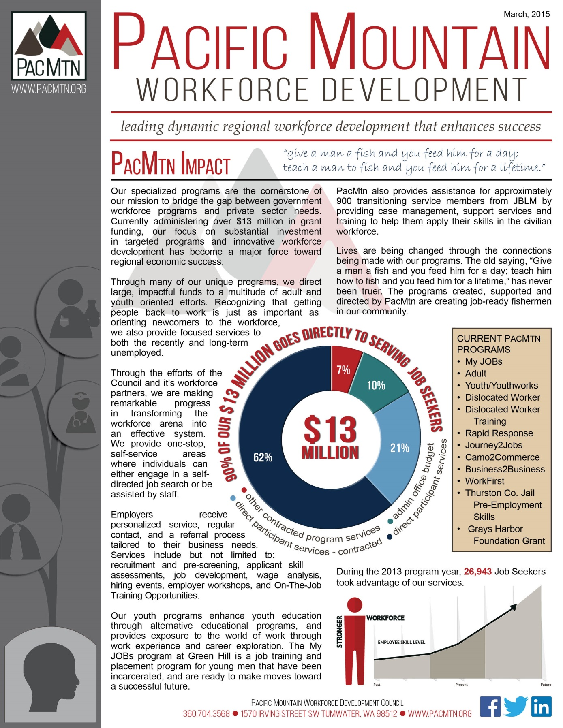
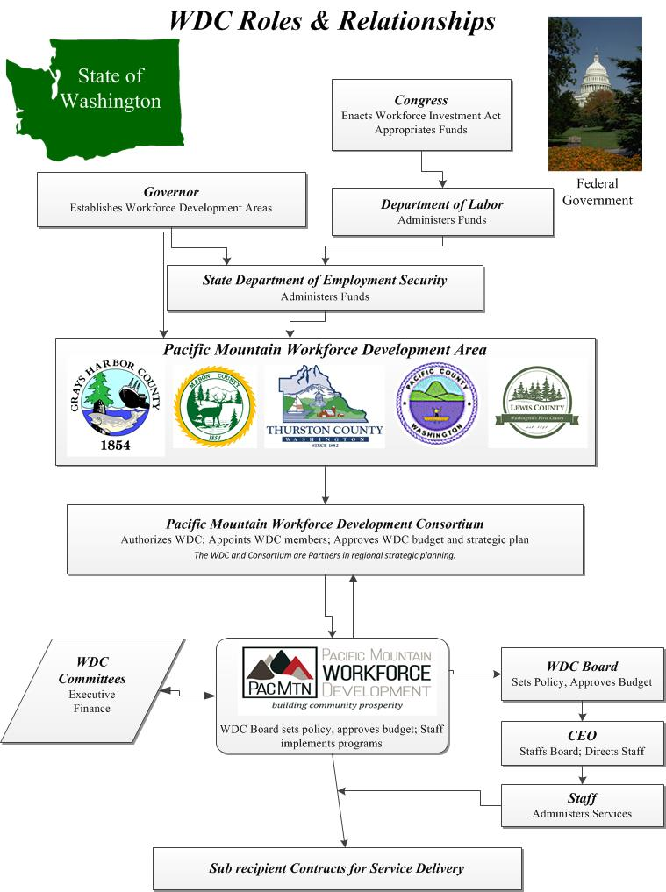At a Glance

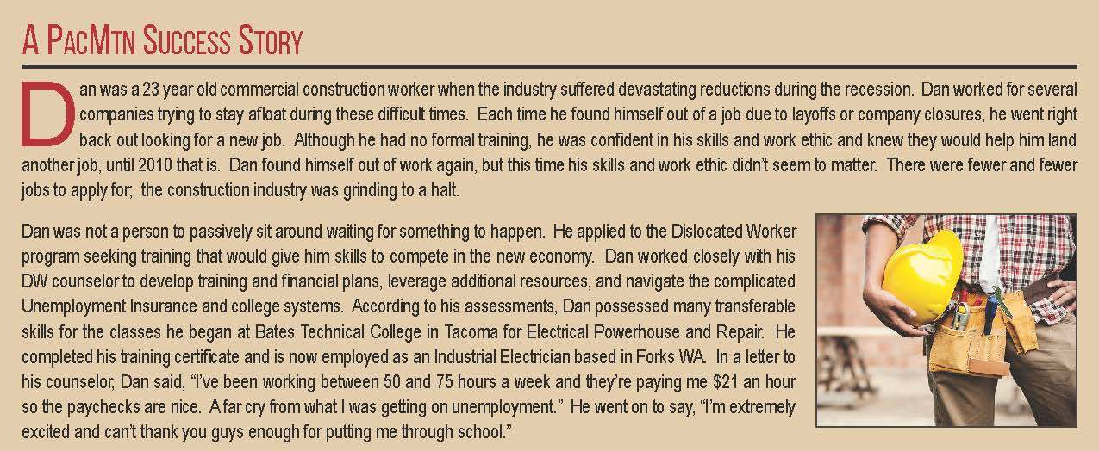
Industry Cluster & Sector Information
The 2012 PacMtn Targeted Cluster Identification & Strategic Alignment Report http://www.pacmtn.org/reports/ focuses directly on the six selected industry clusters:
- Food Production
- Wood Products and Paper Manufacturing
- Life Sciences
- Chemical Production and Plastics Manufacturing
- IT/Telecommunications
- Tourism and Recreation
Food Production
Comprised of industries involved in agriculture production and fishing, as well as the transformation of livestock, agricultural products, and other consumable natural resources into products for immediate and final consumption. The cluster contains supply chain components ranging from agribusiness, transportation/distribution, and final consumption (e.g., supermarkets, restaurants, amusements parks, etc.).
Wood Products and Paper Manufacturing
The core industries range from logging and sawmills to different types of wood manufacturing. Since logging and sawmills are represented within the core industries, the industrial inputs include the engineering and industrial machinery that go into the core industries. Purchasers and distributors include a wide variety of industries such as hospitals, which require a wide range of wood and paper products, and soft drink manufacturing, which primarily buy specific products like cardboard.

Life Sciences
This cluster’s core industries are involved in the development and manufacturing of health-care products, such as electromedical products, as well as specialty and niche medical services, such as laboratories, diagnostic imaging, and kidney dialysis centers. Industries providing administrative and engineering services are represented in the industrial inputs, whereas medical facilities such as dentists play the role of purchasers and distributors.
Chemical Product and Plastics Manufacturing
The core industries are comprised of activities focused on the production of value-add chemicals, such as basic inorganic and organic chemical manufacturing, as well as the production of various plastic products. Inputs to these industries include plastics material and resin products, as well as the research and development behind the manufacturing. Purchasers are mostly within other manufacturing and industrial industries.
IT/Telecommunications
Industries specializing in performing computer programming and data processing related services, including custom services, internet hosting, and other computer-related services, comprise the core industries. This sector is particularly entrepreneurial-focused, given the high number of proprietors and self-employed jobs. The industrial inputs revolve around engineering, administrative, and other service-based industries required by the core industries. The purchasers include a variety of industries, that use the core industries’ services.
Tourism and Recreation
While one additional target cluster, tourism and recreation, was also studied, the leadership team opted to remove it from the regional strategies framework given the predominance of supply-chain industries compared to core industries, the lack of available data for significant tribal operations in the region, and the relatively unique form the industry takes in each part of the region. Recognizing its economic value in the region, participating economic development councils will continue to pursue development of arts, tourism and recreation industries as part of their individual work plans. Additionally, the Pacific Mountain Workforce Development Council recognizes tremendous workforce development opportunities with the tribal communities in the region. Using this document as the basis for dialogue, PMWDC hopes to build and enhance existing partnerships.

Join Us! 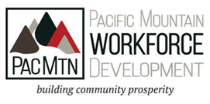
Dear Community Member:
We invite you to consider application for a board position with the Pacific Mountain Workforce Development Council. PacMtn is responsible for workforce development in the five county area of: Grays Harbor, Lewis, Pacific, Thurston and Mason Counties. The Board of Directors provides oversight to the operations of this $13 mil organization and to the important work to create a pipeline of skilled and talented workers who meet the needs of local employers. Pacific Mountain‘s workforce system continues to evolve into a regional, strategically focused and demand driven system. We need business, labor and community members who care about this issue and who will dedicate their time and energy to accomplishing our mission. Learn more about PacMtn @ www.pacmtn.org. Please review the materials included and do not hesitate to call PacMtn offices 360-704-3568 if you have questions. Your attention and contribution to this effort is vitally important to our communities.

Sincerely,
Terri Drexler Duane Evans
PacMtn Consortium Chair PacMtn Board Chair
Mason County Commissioner Port Blakely Tree Farms

Recruitment Overview, Procedures, & Timeline
The members of the Board that represent PacMtn industry sectors are individuals with optimum policy making authority within the businesses, organizations, agencies and other entities. They shall represent diverse geographic areas within the local area.

Composition
Fifteen members of the Board must be representatives of business large and small in the local area and may include private sector employers who represent them (i.e. trade/industry representatives, EDCs and chambers). These members represent businesses, including small businesses that provide employment opportunities that, at a minimum, include high quality, work-relevant training and development in in-demand industry sectors or occupations in the local area. Each of the County Commissions in PacMtn local workforce area will select and forward at least three business representatives who have been nominated by local business and trade organizations.
An additional 11 required regional representatives are appointed for a particular expertise required to achieve the Workforce Innovation and Opportunity Acts intention, meet local needs and should include professionals who serve individuals with barriers to employment and/or eligible youth.
Business Representation (58%) | 15 seats—3 from each County
Required Regional Representation | 11 seats—region wide
TOTAL | 26 seats

Nomination
All appointments will be made by the PacMtn Consortium. Nominations shall be received from:
- 3 business representatives per county —15 seats total
- Recommended by each County Commission following nomination and consultation with local business organization and business trade associations
- 2 seats—Organized Labor
- Nominated by Local Labor Federations and Organizations
- 1 Seat—Apprenticeship
- Nominated by Local Labor Federations and Organizations
- 1 Seat—State Employment Services
- Nominated by Employment Security Department Commissioner
- 1 Seat—Disabilities-based Employment/Training
- Nominated by Department of Vocational Rehabilitation Director
- 1 Seat—Adult Education and Literacy
- Nominated by Local Adult and Basic Education Contractors
- 1 Seat—Postsecondary Higher Education
- Nominated by Post-Secondary Presidents
- 1 Seat—K-12 Education
  - Nominated by Office of the Superintendent of Public Instruction, Education Service District 113, Superintendents Association, Principals Association
- 1 Seat—Department of Social and Health Services Economic Services Administration
- Nominated by DSHS Economic Services Assistant Secretary
- 2 Seats—Community Based Organizations and/or Tribes whose workforce mission aligns
- Nominations are open from all of the above nominators and community based organizations that serve the specialized populations and expertise desired by the Board and Consortium

All nominations are received by PacMtn WDC Board Nomination Review Committee, appointed by the WDC Chair. The Review Committee works with staff to reconcile packages in accordance with direction of the Consortium, adopted Board Member job description and directives of the strategic plan. All nominations will be forwarded for consideration and appointment, as agreed by the Consortium.

Board Member Job Description
The purpose of the Workforce Development Council (WDC) is to be the region’s expert and leader in workforce development. The WDC is led by a dedicated group of labor, business and community leaders focused on the mission to build community prosperity. The Council will identify workforce issues and concerns and bring together the necessary assets to facilitate solutions that foster prosperity for the region, local business and industry, and residents. The WDC strategically plans and deploys workforce solutions and resources for the advancement of region’s economy. The WDC gathers and disseminates information about the area’s labor market and businesses’ employment needs; builds a strong area-wide workforce development system of partners; convenes groups of businesses, training providers, and other organizations to develop solutions for workforce challenges; and oversees the local network of America’s Job Centers, called WorkSource in Washington State. Board Members are appointed by the PacMtn Consortium and will report semi-annually to the County Commissioners and/or at the request of the Commissioner.

Qualifications
- Desire to make a positive contribution to the regional economy by helping shape a workforce development system that meets the needs of employers and individuals.
- Willing to devote time and talent to work with other Board members, staff, businesses, public officials, and public and private sector partner organizations to achieve PacMtn’s mission to enhance the quality of the workforce.
- Demonstrated team player committed to creating and contributing to a positive environment
- Employed as a senior-level decision-maker in your organization and willing to think about the region as a whole--not just the interest of your business and organization.
- Conducts oneself with the highest levels of professionalism as a thought leader and visionary, respected in their communities
- Community minded individual with demonstrated interest and capacity to enhance and expand the credibility of the workforce system and its partnerships.
- Business Representatives:
  - Represent all sizes of business and industry with adequate employees to understand labor force needs/issues;
  - Clearly understand the need for a well trained workforce and the workforce skills needed by 21st century employees
  - Stand ready to represent a whole industry (cluster/sector), with credibility, knowledge and experience in that sector/cluster and to speak to regional industry trends and needs
Expectations
- Attend 75% of scheduled Board and assigned committee meetings.
- Join and actively participate in at least one standing committee of the Board.
- Notify the Board chair or the executive director when you are unable to attend meetings.
- Act as an ambassador of the workforce system in community and business groups in which you are involved.
- Utilize, to the greatest extent possible, the business and partner resources of the local WorkSource.
- Educate yourself and remain updated on current and contemporary workforce issues and PacMtn activities.
- Be prepared for Board meetings by staying informed about Board matters, reviewing materials sent in advance of the meetings.
- Get to know and respect other Board members, building collegial relationships that contribute to effective decision making.
- Act and vote on behalf of the long term interests of the regional labor force, employers and the community and not on the interest of a single constituency.
- Avoid conflicts of interest. If a conflict on a particular issue is unavoidable, disclose the conflict and follow Board policies for removing oneself from discussion and/or vote on that issue.
- Understand and observe the respective roles of the WDC, Board staff, the One-Stop Operator, service providers and the Chief Elected Officials.
- During Board meetings focus on policy elements, operating at the 30,000 foot level, not in the staff level details.

Complete description of duties and responsibilities can be found at: http://www.pacmtn.org/board-members/
Time Requirements
- The Board meets monthly with meetings normally lasting from two to four hours. To accommodate schedules and the vast travel distances of this region participation through on-line or teleconference meetings are encouraged. Upon request travel expenses will be reimbursed.
- Committees generally meet monthly, with some variance upon needs as determined by the Chair, specific projects and desired deliverables.
- Members are encouraged to perform ambassador duties as part of their regular job functions and through existing professional networks.
- Individuals are appointed into two, three or four year terms, as designated by the PacMtn Consortium.
Board Committee Work
Pursuant to the Federal Workforce Innovation and Opportunity Act H.R. 803 the Board may designate and direct the activities of standing committees to provide information and to assist the local Board in carrying out required activities. All standing committees shall be chaired by a member of the Board and may include other members of the Board, and other interested community stakeholders and subject matter experts appointed by the Board. Committees and Taskforces must be chartered and accepted by a vote of the full Board.

Proposed PacMtn Committees and Taskforces :
- Executive Finance Committee – comprised of the WDC Board Chair, Incoming Chair, Vice Chair, Secretary/Treasurer, Immediate Past Chair and chairs of all Taskforces and assigned Committees. Should all counties not be represented in this group a Member at Large will be added until such time as all counties are represented.
- Youth Services Taskforce – responsible for oversight of youth services and initiatives.
- One Stop and Program Operations Taskforce – responsible for oversight of the One Stop System, and activities related to service delivery and programs.
- Special and Targeted Populations Taskforce- responsible for oversight of planning and programming related to people with disabilities and other populations for which the Board desires specific and focused attention.
- Industry Sector and Employer Services Taskforce- responsible for oversight of the initiatives specific to industry and employer services. They are also directly sought for matters related to One-Stop, Program and Special Populations.

Code of Conduct & Conflict of Interest
The Workforce Innovation and Opportunity Act, Section 107(h) Conflict of Interest states that a member of a local Board, or a member of a standing committee, may not:
- vote on a matter under consideration by the local Board;
  - regarding the provision of services by such member (or by an entity that such member represents); or
  - that would provide direct financial benefit to such a member or the immediate family of such member; or
- engage in any other activity determined by the Governor to constitute a conflict of interest as specified in the State plan.
PacMtn Code of Conduct/Conflict of Interest Policy: http://www.pacmtn.org/wp-content/uploads/110-R2_Code_of_Conduct_ContactNameChange.pdf
Board Member Application & Process
- Nominee fills out board member application
- Nominating body prepares nomination letter
    - Nomination letter should be on organization letterhead and signed by nominator
    - Nomination letters should include a brief biography of nominee and address the nominee’s skills, background, and interest in serving on the board.
- Nominator or Nominee sends complete application (application and nomination letter) to:
    - Vanessa@pacmtn.org
    - Email Subject: PacMtn Board Member Nomination

Board Member Application

Contact information
First Name: |  |  |  |  |  |  | Last Name:
Address:
City: |  |  |  |  |  | County: |  |  |  |  |  | Zip:
Email: |  |  |  |  |  |  |  |  | Phone:
Employer: |  |  |  |  |  |  |  | Position Title:

Representation
 | Business/Private Industry:
 | County: |  |  |  |  |  |  | Sector: |  |  |  |  |  |  |  | Number of Employees:
 | Organized Labor:
 | Apprenticeship:
 | State Employment Services:
 | Disability-Based Employment/Training:
 | Adult Education and Literacy:
 | Post-Secondary Higher Education:
 | K-12 Education:
 | DSHS-Economic Services Administration:
 | Community Based Organization:
 | Tribal Entity:

Questions
- What do you think are the key Pacific Mountain regional workforce issues facing employers and job seekers?
- What interests you about the Pacific Mountain Workforce Development Council? Which aspects of workforce development interest you the most?
- What skills, connections, resources, and expertise do you have to offer and are willing to use on behalf of the Pacific Mountain Workforce Development Council and its employer and job seeker customers?

Nominee Signature
Signature | Date

Thank you!
For your interest in serving on the Pacific Mountain Workforce Development Council

