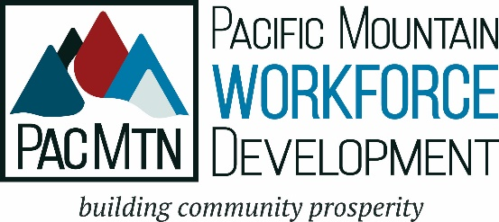

FOR IMMEDIATE RELEASE:
August 6, 2021

Contact:
Kelly Fujimoto, Community Relations Analyst
PacMtn Workforce Development Council
kelly@pacmtn.org
360-704-4653

PacMtn Workforce Development Council CEO Announces Retirement

Olympia, Wash. – Cheryl B. Fambles has announced her retirement as CEO of the Pacific Mountain Workforce Development Council after nearly 10 years in the agency’s top job. “Cheryl has truly been a transformational leader for PacMtn. She has expanded the reach and deepened partnerships with the business community, educational institutions, and community-based organizations,” said Jacquelin Earley, Board Chair. “Since she arrived we have seen tremendous increase in the revenues and diversity of services PacMtn offers. She is a passionate and courageous leader. The Board is especially proud of the cutting-edge work PacMtn does with those in poverty, those transitioning out of the military and those returning to our communities from the justice system. This is challenging work and she has made it a priority for PacMtn.”
Ms. Fambles leads the federally designated, public workforce agency serving the five counties of Grays Harbor, Pacific, Lewis, Thurston and Mason Counties. Working with a complex network of partners, a staff of 30, and multiple contractors, PacMtn is responsible for identifying and implementing appropriate workforce solutions for both employers and those needing jobs and family sustaining careers.
The PacMtn Executive Committee has begun the search for Ms. Fambles’ replacement, using Jeanne Bennett Consulting to find and vet qualified candidates. The Board intends the position be filled ahead of Ms. Fambles’ departure at the end of January.

For more information, don’t hesitate to contact Kelly Fujimoto, Community Relations Analyst, kelly@pacmtn.org.

# # # # #

About PacMtn Workforce Development Council (PacMtn):
PacMtn is a nonprofit organization that is the recognized convener of regional workforce development efforts. The PacMtn Board of Directors, PacMtn elected Official Consortium, and all staff are dedicated to the development of a workforce system that supports business, industry, and all levels of employers and job seekers. PacMtn oversees the regional network of American Job Centers, called WorkSource, which house the demand-driven and integrated system of partners dedicated to developing community prosperity, one job seeker and one employer at a time.

